**First web cloning**

Spotify

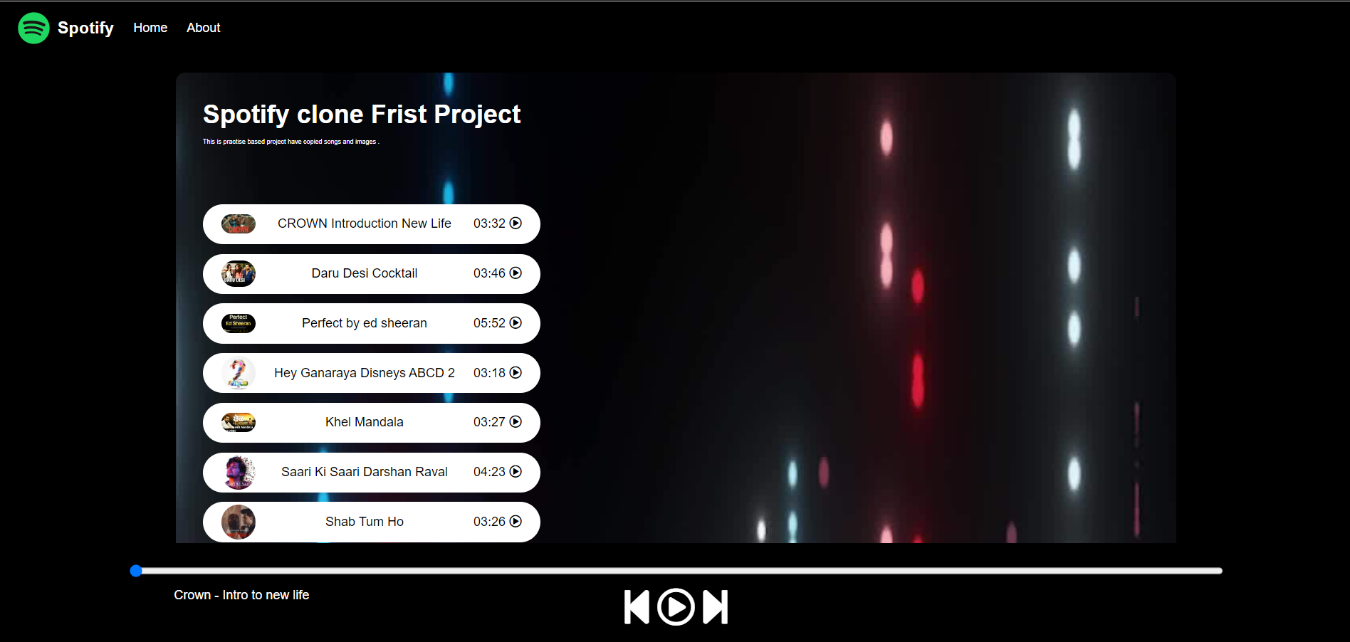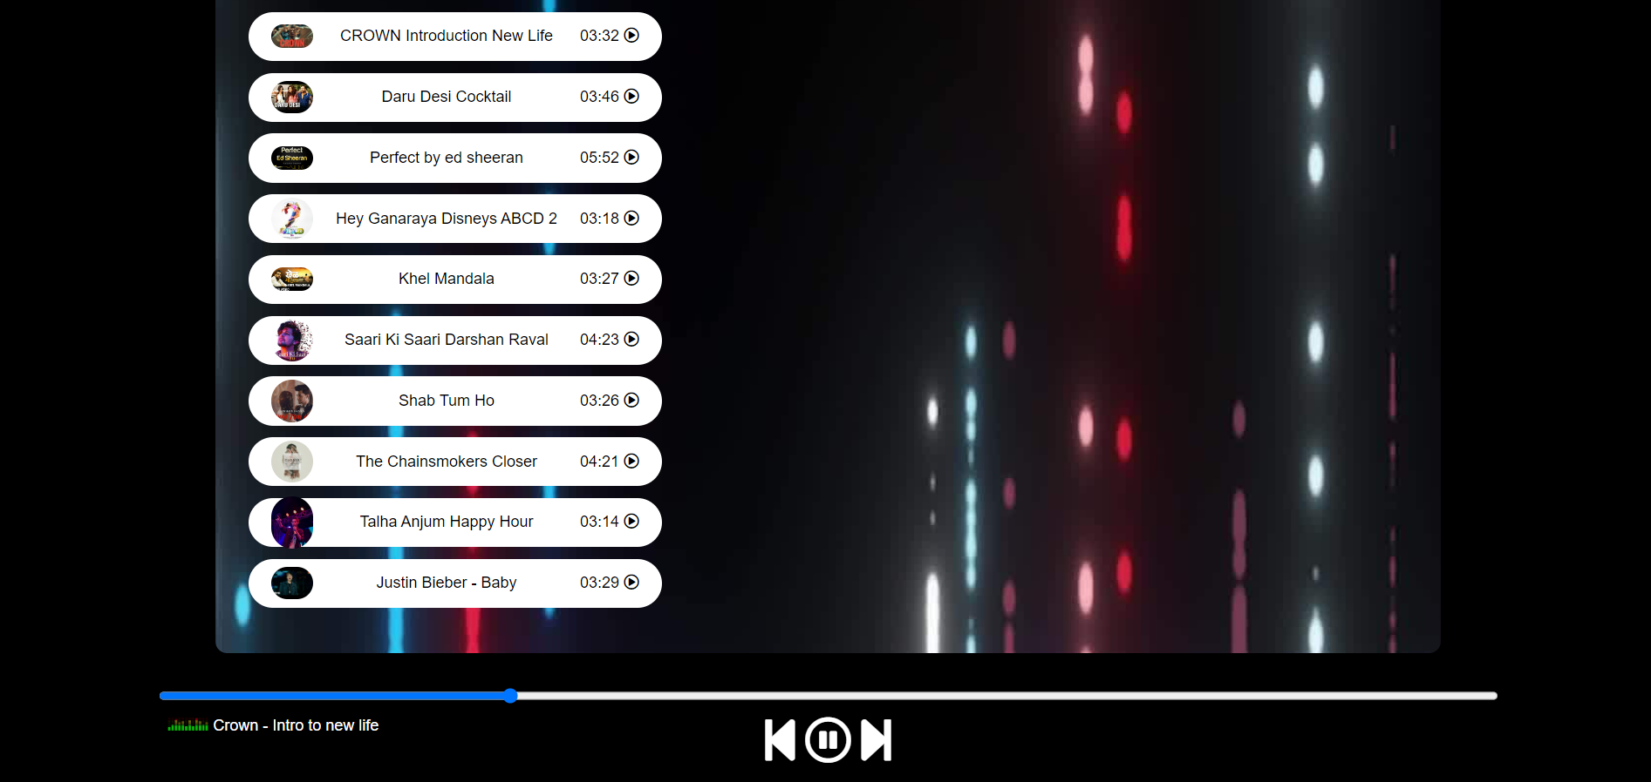

* Basic project
* Includes 10song
* With their plays

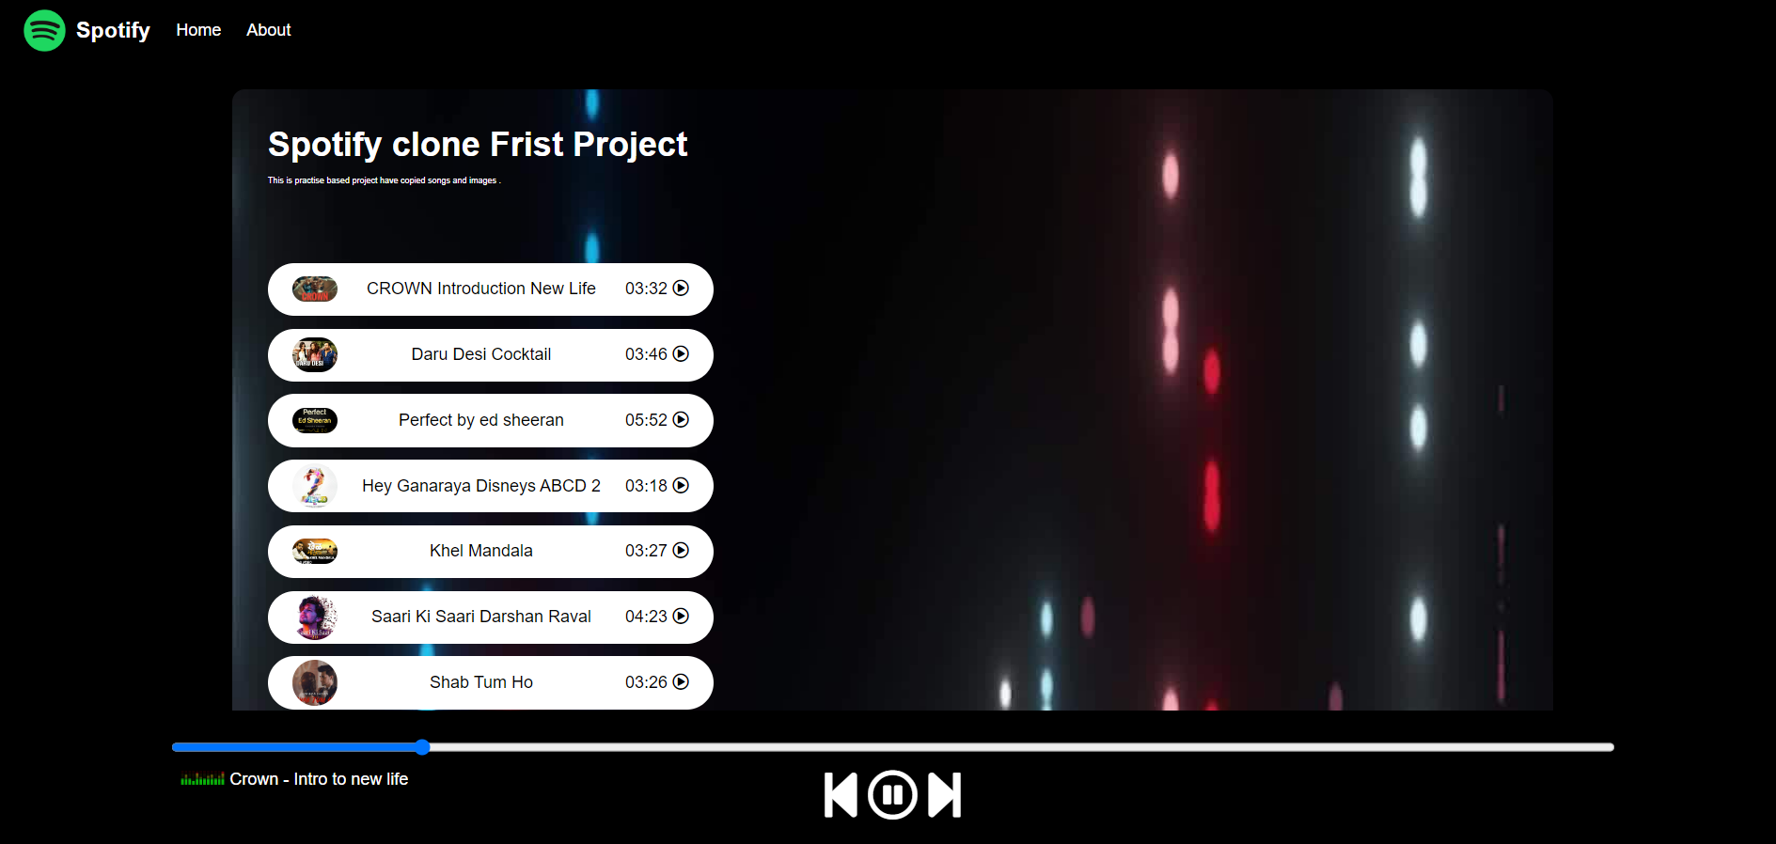

Used Languages

* Html
* CSS
* Javascript